

**Pasture Information Session**

**28th January 10:30am**

**At the Murrabit Lawn Tennis Club**

Guest speakers

Mark Palmer-Stephens Pasture Seeds

Hamish Mines- Wengfu Fertiliser

Barry Murphy- Olsson’s Stock Licks

Followed by a BBQ Lunch

Everyone welcome

Any enquires PH 54572235

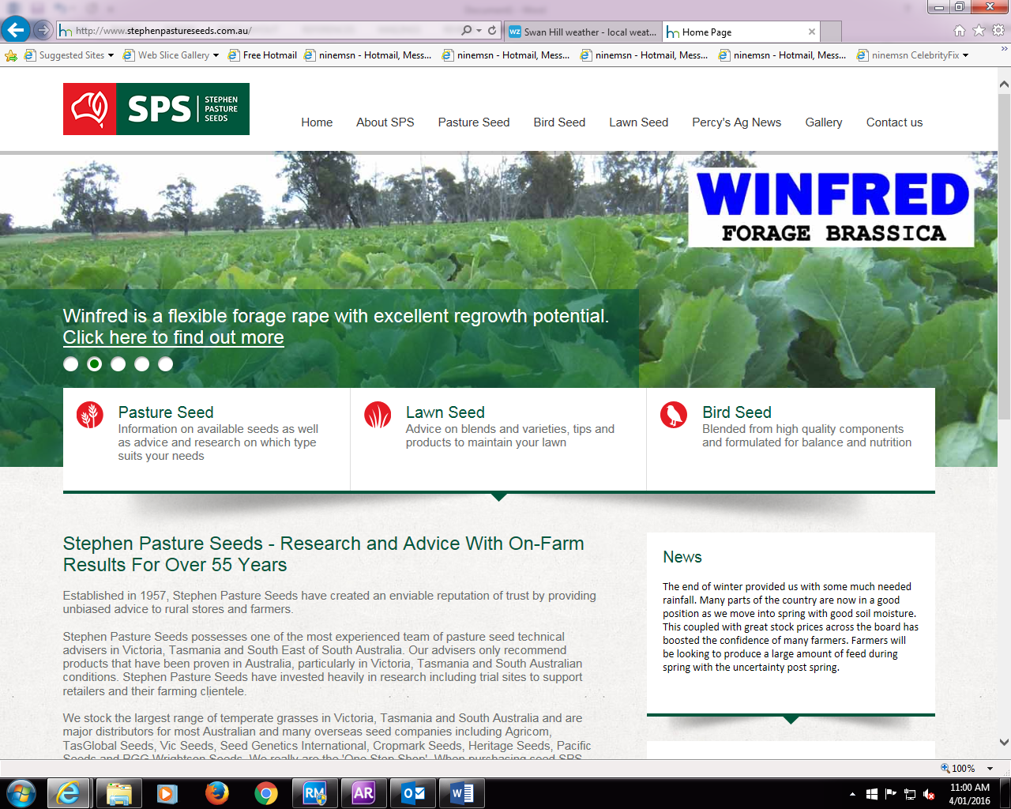[](http://www.olssons.com.au/)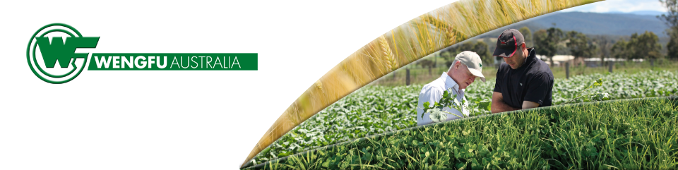



* **How to select pasture seed to suit your property**
* **Sowing hints**
* **Fertiliser for new pasture**
* **Grazing and managing a new pasture**
* **Sowing rates**
* **Heading dates of perennial, annual and hybrid ryegrasses**
* **Endophyte options in ryegrasses and fescues including AR37 and MaxP®**
* **Knight Italian ryegrass**
* **Brome, prairie, cocksfoot grasses**
* **Forage cereals, oats, triticale**
* **Perennial grazing herbs - Tonic plantain and Choice chicory**
* **Clovers - subs, red, white, annual, arrowleaf, strawberry**
* **Vetch, serradella, forage brassica**
* **Seed treatment - SowEasy and SPS KickStart®**
* **Nodulator granules**

[](http://www.olssons.com.au/)

**Olsson’s manufacture salt products & nutritional supplements for livestock, such as cattle, sheep, goats, horses, etc.**

**Olsson’s 1st salt block was produced in 1949. It was the first pressed salt block produced in Australia to contain a range of minerals and was the forerunner of all the multi-nutrient blocks produced in Australia from that time onwards.**

**Olsson’s have been at the forefront of ruminant technology and education of the grazier about the latest break-throughs in this field. Olsson’s continue to support the research and development of ruminant nutrition through University tests and field trials.**



**Wengfu is one of the largest phosphate fertiliser manufacturers in the world and now has an Australian headquarters.  Our Australian operation is focused on the needs of local farming enterprises and has developed products to meet the specific requirements of cropping and pasture in Eastern Australia.  
   
Wengfu Australia is all about providing you with an efficient advantage.  We’ve gone beyond traditional fertilisers and taken an innovative approach to our products to deliver the very best products to maximise yields.**