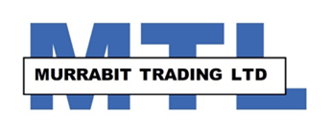 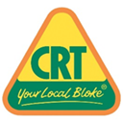

**RURAL BUSINESS MANAGER**

An excellent Career opportunity in a regional CRT store, is open to someone who has a passion for agriculture.

Murrabit Trading Ltd is a farmer owned co-operative trading since 1925. Murrabit is located on the picturesque Murray River, in small but vibrant community. Murrabit has its own Football/Netball club, Lawn tennis club, Golf club, Primary School and hosts the famous monthly “Murrabit Market”.

Servicing clients in both Victoria and New south wales, you would be required to maintain and develop the existing strong working relationships, and expand the client base.

We supply a complete range of rural merchandise as part of the CRT network and are looking for a full time business manager who ideally would have, but not essential the following qualifications and skills:

Ability to manage and work within a team environment, reporting to the board of directors.

Good knowledge of current agricultural practises in both dryland and irrigation farming

Excellent communication, reporting and record keeping skills.

Basic knowledge of MYOB and Microsoft office

Hold a forklift license and Agsafe accreditation

Understanding of OH&S requirements

**You must have:**

A current driver’s license,

Previous rural merchandise experience.

A strong sense of customer service and satisfaction

Attention to detail and a professional approach

A negotiable salary package including a motor vehicle is available.

To apply, email your covering letter and resume addressed to

“The chairman MTL”

Attention Andrew [asurv@bigpond.com](mailto:asurv@bigpond.com)